CHAPTER 8: The dynamic Earth

Worksheet 8.2

Plate tectonics
Answers

Movement in the South Atlantic
1. The following diagram shows the ocean floor of the South Atlantic Ocean.
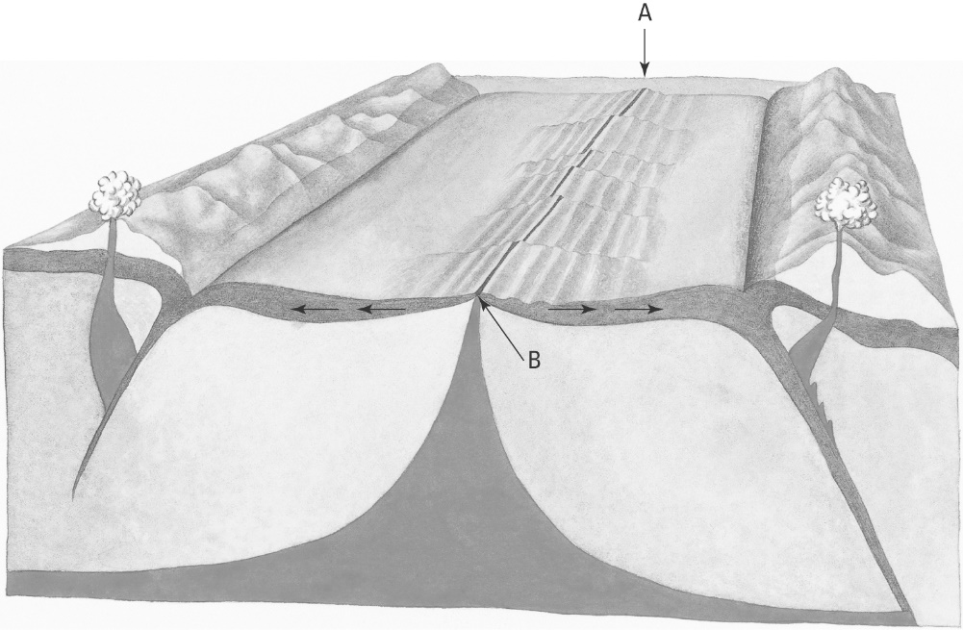
Mid-ocean ridge (Mid-Atlantic ridge)
(a) Identify the feature labelled A.
Magma
(b) Identify the material rising up to the surface at B.
(c) On the diagram draw in the convection currents in the upper mantle (asthenosphere).
Convection currents

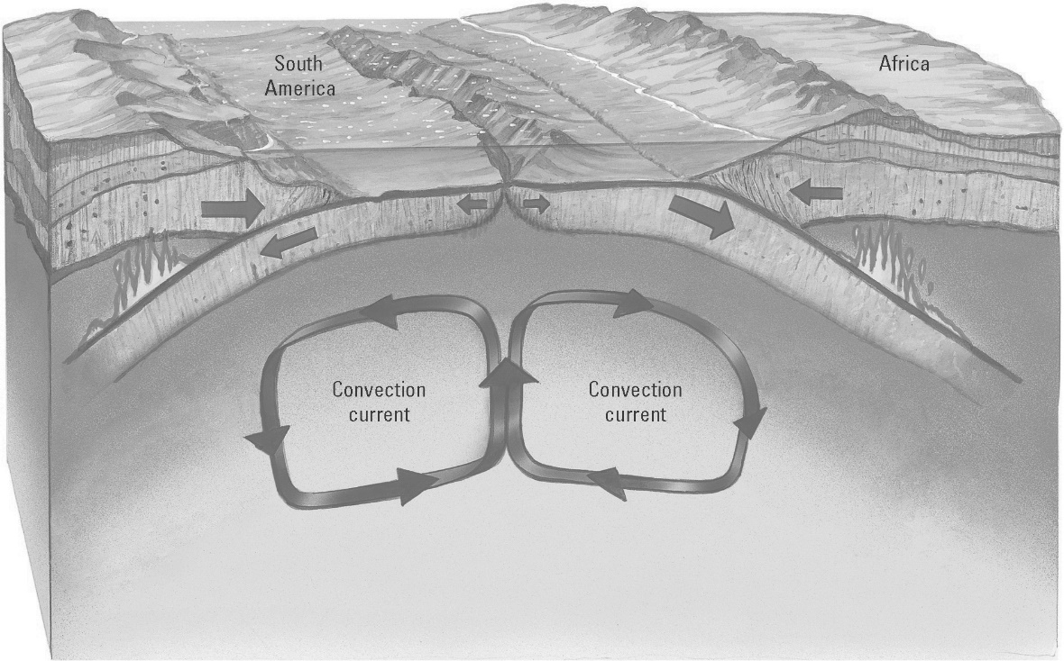
(d) Explain why the South American plate and the African plate are moving apart.
The rising magma causes the sea floor spreading. Forces from the rising magma push the plates apart.

CHAPTER 8: The dynamic Earth

Worksheet 8.2

Page 2

North of Australia
2. The following map shows the Australian–Indian plate, and other plates to the north. The arrows show the direction of plate movement.
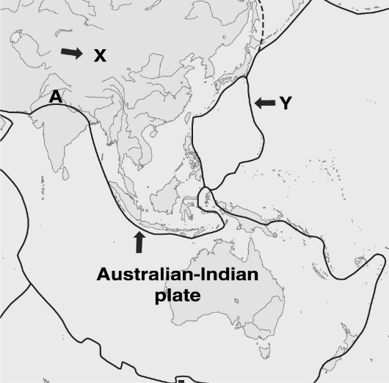  © MAPgraphics Pty Ltd, Brisbane | (a) Name plates X and Y.  Eurasian plate  X:  Pacific plate  Y:  (b) Name the type of plate interaction at location ‘A’.  Converging plates — collision zone  (c) Name the geological feature resulting from the plate interaction at A.  Mountains (Himalayas)

